21. Implement a C Program for an Array to sort in ascending order.

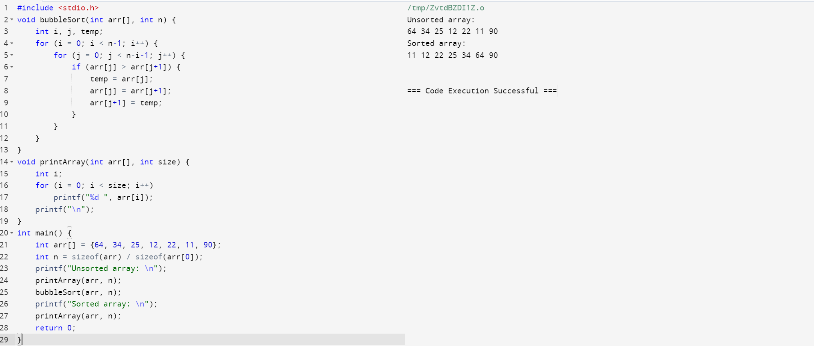

22.Implement a C Program to Print no of nodes in the given linked list.

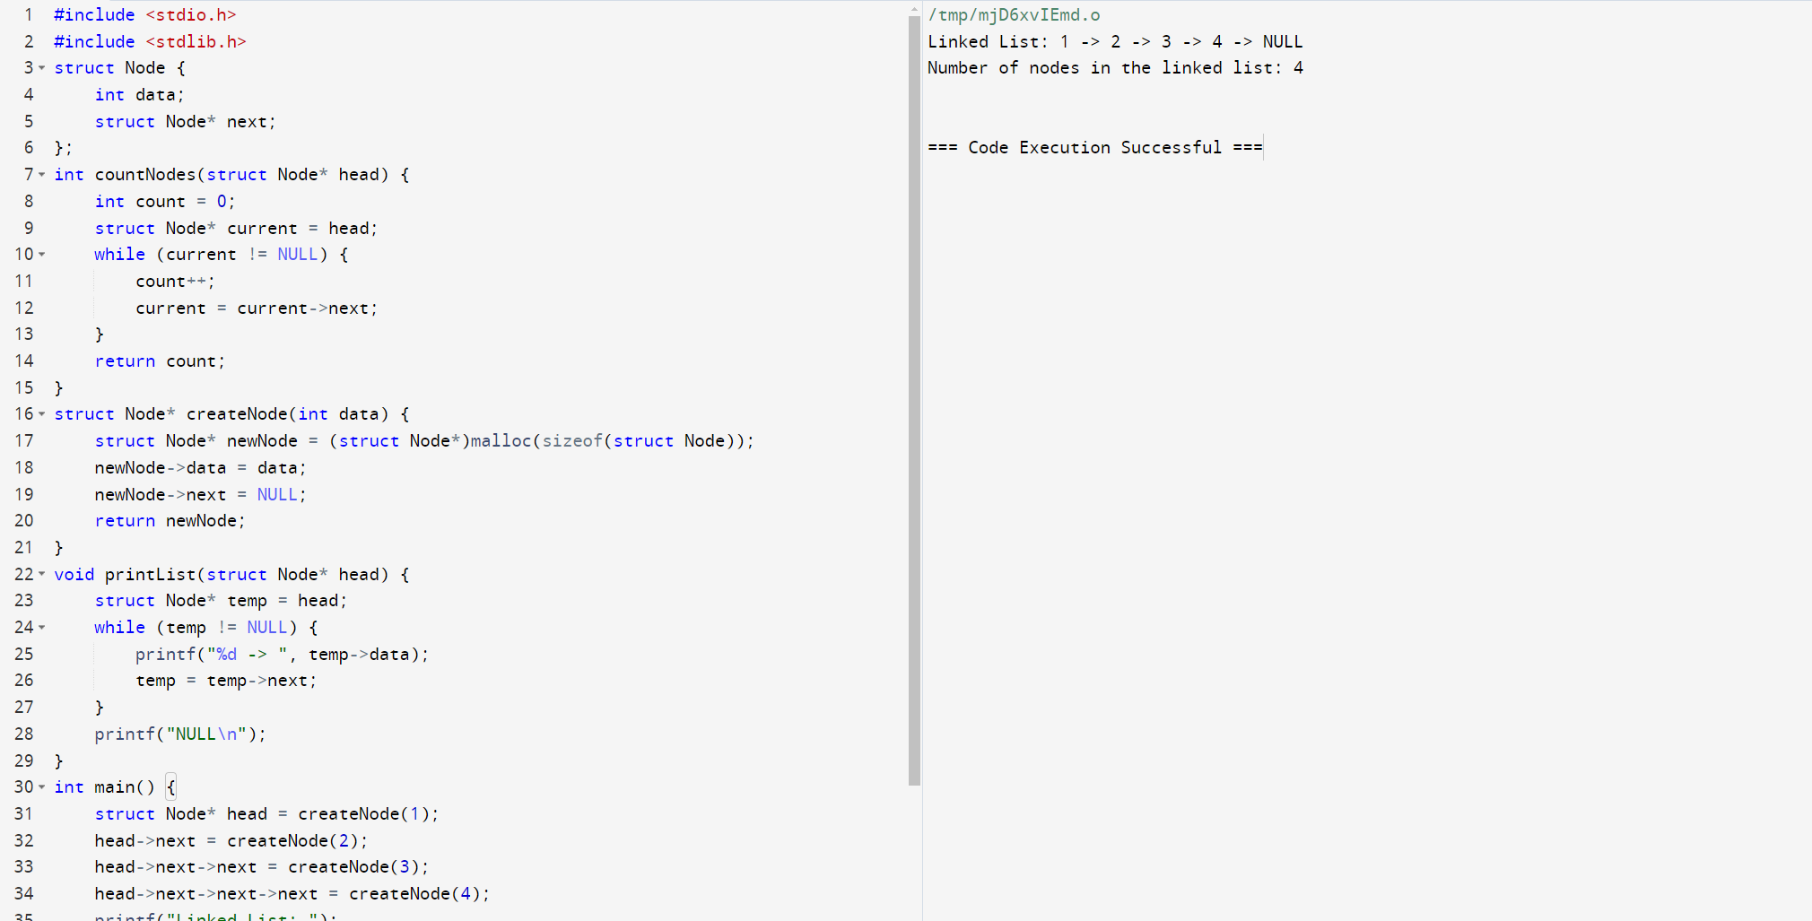

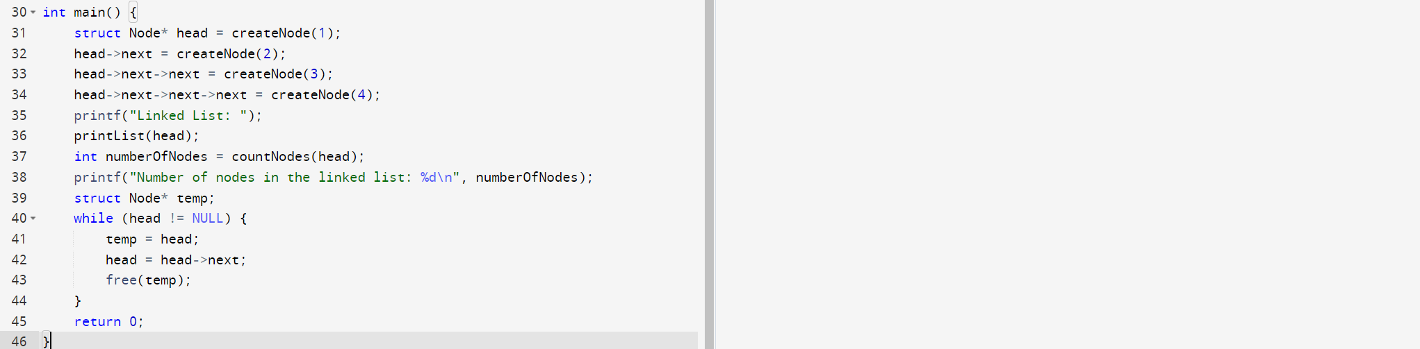

23. A Implement a C Program to perform search for sorted elements.

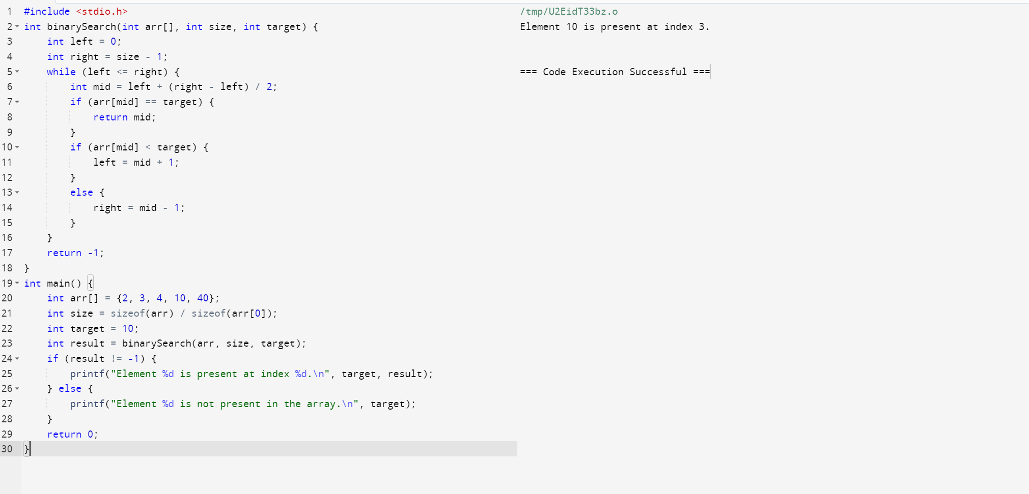

24. Implement a C Program to Print the index of repeated characters given in an

Array.

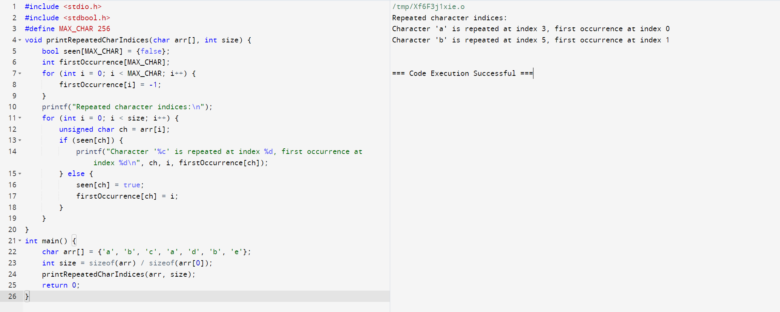

25. Implement a C Program for given set of Array elements - display 5th iterated

Element.

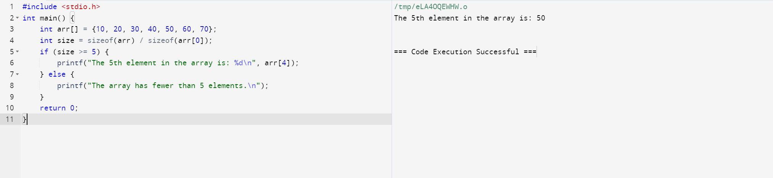

26. Implement a C Program to perform Palindrome using SLL.

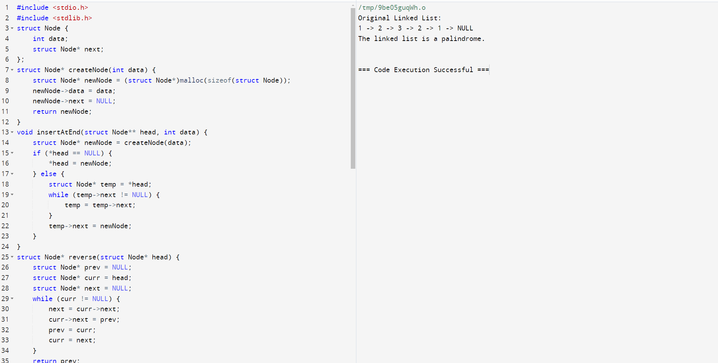

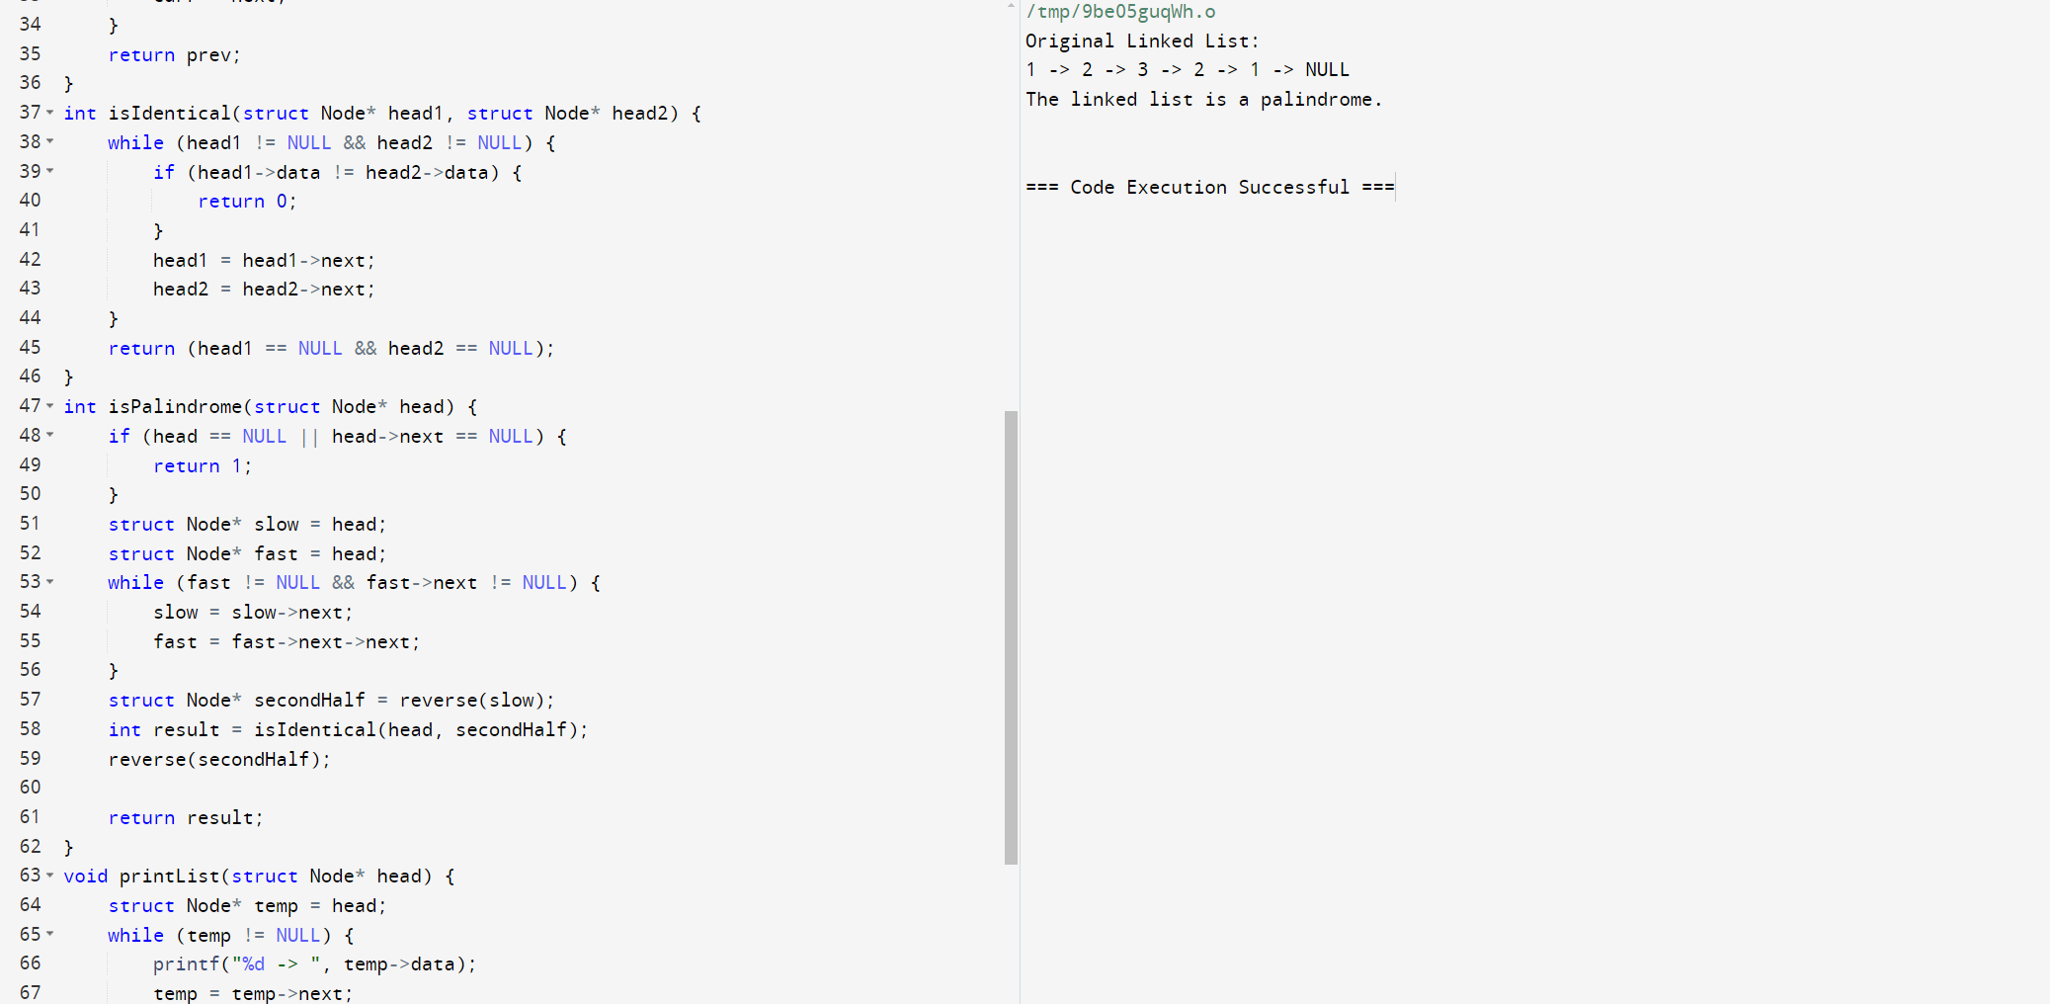

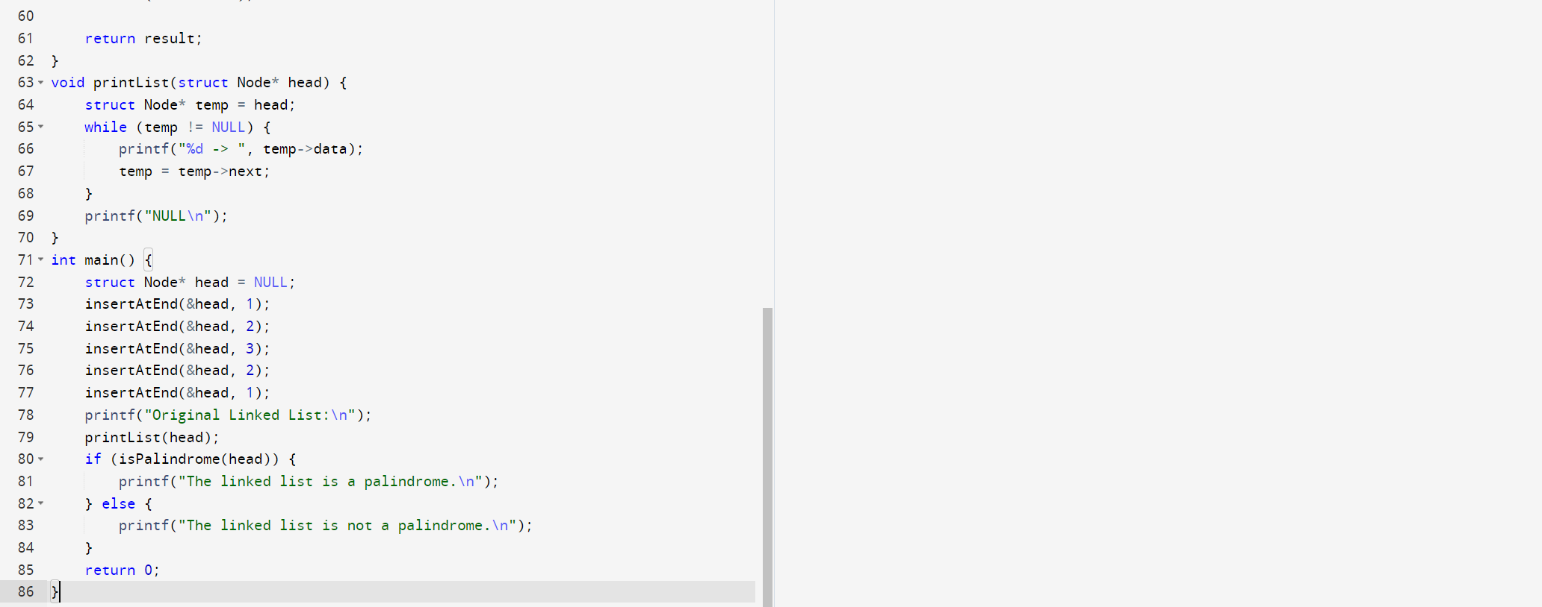

27. Implement a C Program for Given unsorted array - Display missing element

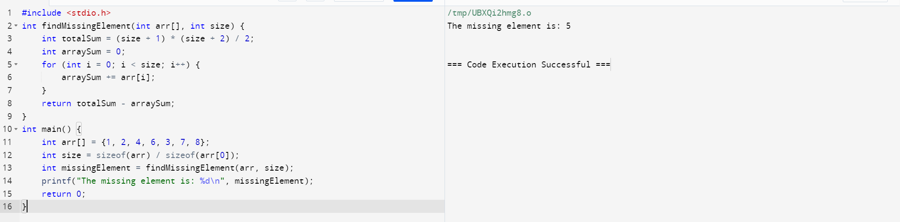

28. Implement a C Program for a Binary tree

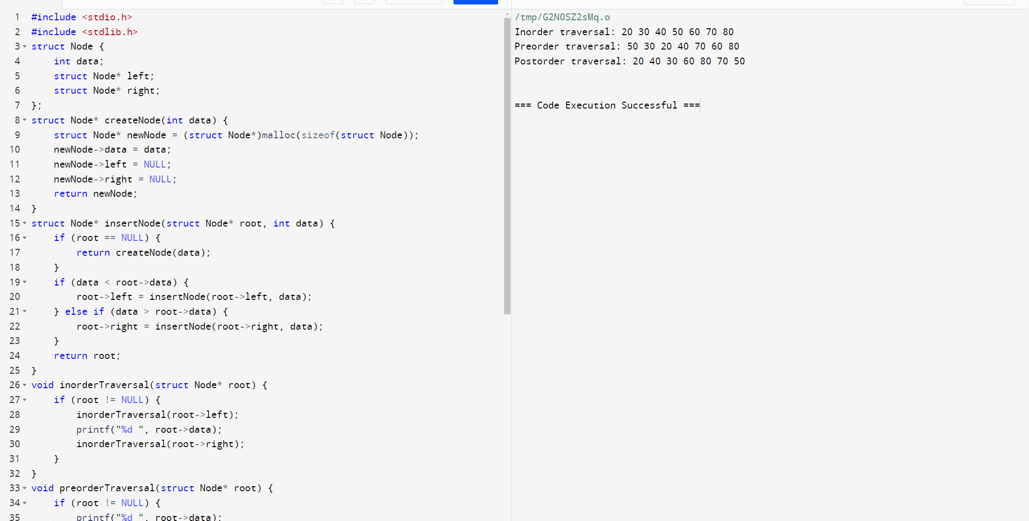

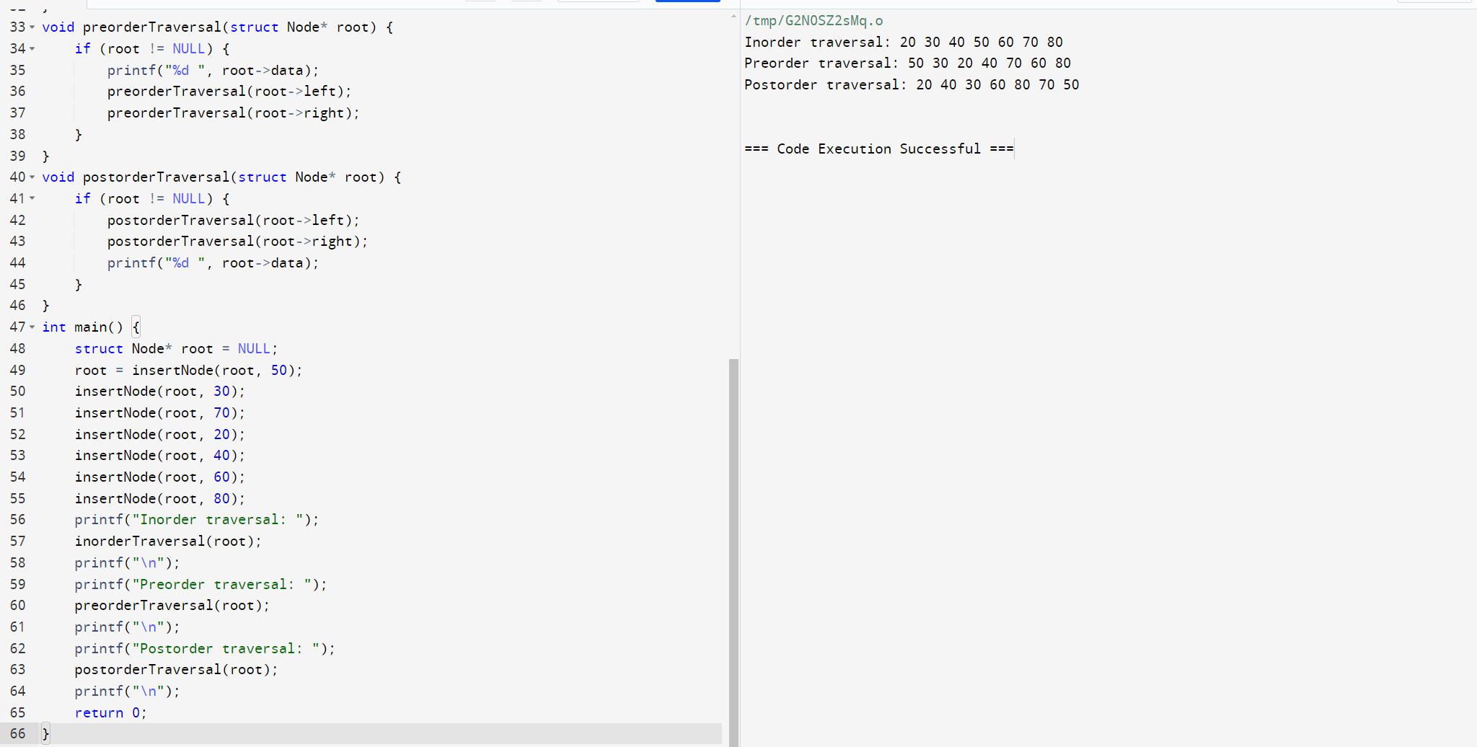

29. Implement a C Program for Array concatenation.

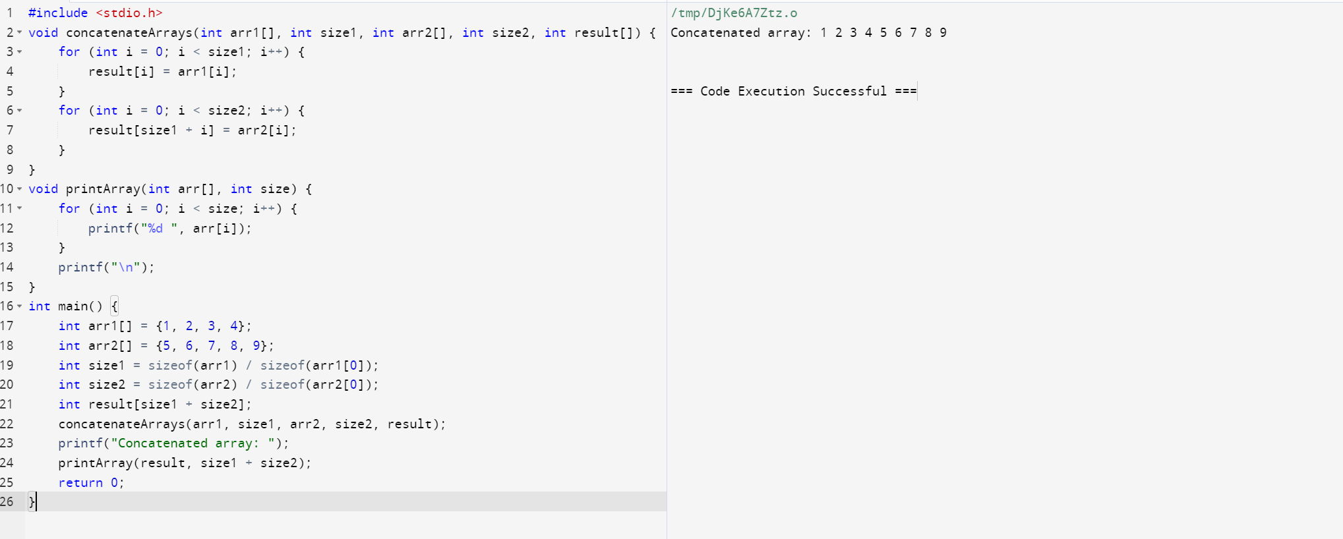

30. Implement a C Program to perform stack using two queues.

